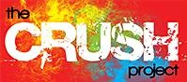
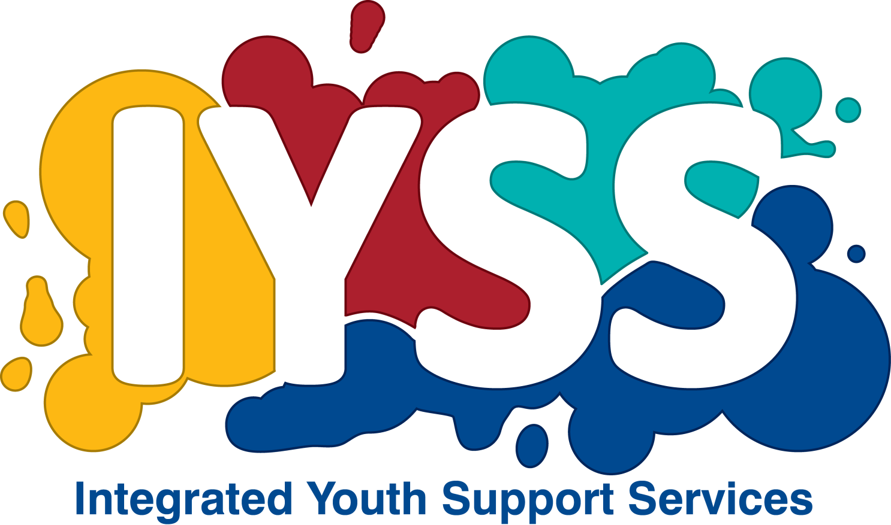

Helping young people make safe and healthy relationships

What is CRUSH?

CRUSH is all about helping young people make safe healthy relationships. It's a structured group programme of support and empowerment for young people in the age range of 13-17yrs who have witnessed, experienced or are at risk of domestic abuse. CRUSH aims to help young people gain the skills, knowledge and tools to be able to:

- Avoid abusive relationships
- Exit an abusive relationship safely
The CRUSH Programme is suitable for young people of both sexes and can be helpful to those who are vulnerable to domestic abuse and also for those who are beginning to show signs of controlling behaviour.

If you would like to refer a young person into the programme please complete the CRUSH referral form. Please be aware that this does not guarantee a place on the programme as we need to assess risk and vulnerability to ensure suitability and safety for all group members.

CRUSH has been evaluated and endorsed by the University of Worcester as a safe and appropriate programme for young people.

If you would like to discuss the programme, please contact Donna-Mae Kearns or James Kendall on 01803 20840o or alternatively you can email; james.kendall@torbay.gov.uk / donna-mae.kearns@torbay.gov.uk

