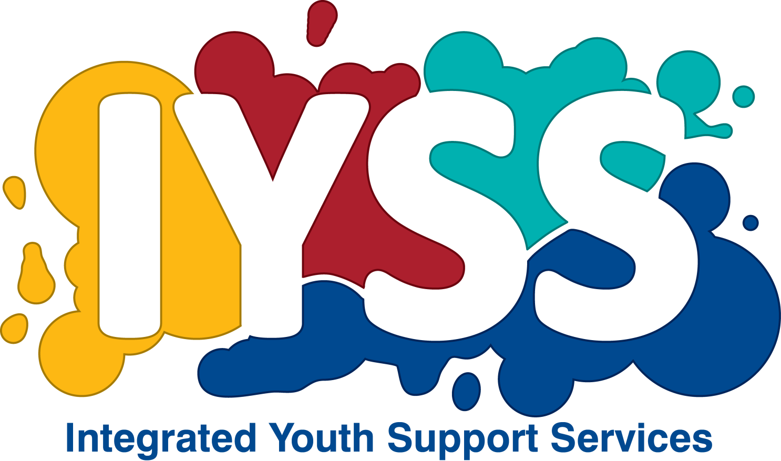
INTEGRATED YOUTH SUPPORT SERVICES
TORBAY COUNCIL
Tel: 01803 208400

REFERRAL CRITERIA: 14-16 year olds who have witnessed and/or experienced
domestic abuse.
Referral type
Agency/organisation
Name of contact
Contact number
Email
Have you completed a risk assessment? |  |  |  |  | YES / NO
Why are you referring the C/YP to the crush programme?
Full name
Preferred name
Dob |  |  |  |  |  |  | Age
Gender
Address
Preferred method of contact |  |  |  | Call landline
 |  |  |  | Call mobile
 |  |  |  | Text
 |  |  |  | Email
Is it safe to |  |  |  | Call
 |  |  |  | Leave a voicemail
 |  |  |  | Unsafe
Best time to contact
Does the YP have any medical conditions, disability or mobility problems or problems using stairs or visual/hearing impairment?
YES / NO
Does the YP require language or literacy support?
YES / NO
Is the YP from a BM or cultural group?
YES / NO
Is the YP being supported by another agency, such as social care, probation, mental health, substance worker, YOT?
If YES please give brief details.
YES / NO
Is the YP using substances?
YES / NO
Is there anything else we should be aware of in order to ensure the YP’s comfort or safety – or the comfort or safety of staff and others?
e.g.: is the YP known to be violent or aggressive?
YES / NO
Is the YP at risk of domestic abuse in their current relationship?
YES / NO
Has the YP experienced domestic abuse in a past relationship?
YES / NO
Is or has the YP been exposed to domestic abuse at home?
YES / NO
Does the YP have a child protection plan in place or involvement with Children’s Services?
YES / NO
If YES, please give brief details including social worker’s contact details.
YES / NO
Is the YP a looked After Child?
YES / NO
Is the family involved or been involved with MARAC?
YES / NO
What type of abuse is the YP experiencing? Please tick all that apply.
 | None |  |  |  |  |  |  | Risk of abuse in current relationship
 | Experienced abuse in the past |  |  |  |  |  |  | Exposed to abuse at home
 | Physical abuse |  |  |  |  |  |  | Emotional abuse
 | Financial abuse |  |  |  |  |  |  | Sexual violence or exploitation
 | Showing perpetrator traits and/or characteristics |  |  |  |  |  |  | Family involved with a CAF
 | Protection plan in place with Children’s Services |  |  |  |  |  |  | Family involved with MARAC
 | Involved with prostitution |  |  |  |  |  |  | Risk of forced marriage
 | Stalking or harassment |  |  |  |  |  |  | Risk of Honour based violence
 |  |  |  |  |  |  |  | At risk of being trafficked
Who is the YP experiencing abuse from and what is their relationship?
Brief background history of abuse. Including how longs the abuse has been happening, the severity and frequency of the abuse.
If the YP is under 16, has parental consent been given or has someone with parental responsibility given consent for the YP to attend a CRUSH programme?
YES / NO
What procedure should we take in an emergency?
Name
Address
Phone number
Relationship
Can the YP safely attend a session and keep the service and venue confidential from any abusive party?
PLEASE NOTE: All referrals will be looked at on an individual basis to consider risk and vulnerability. Not all referrals will be accepted as a result.

