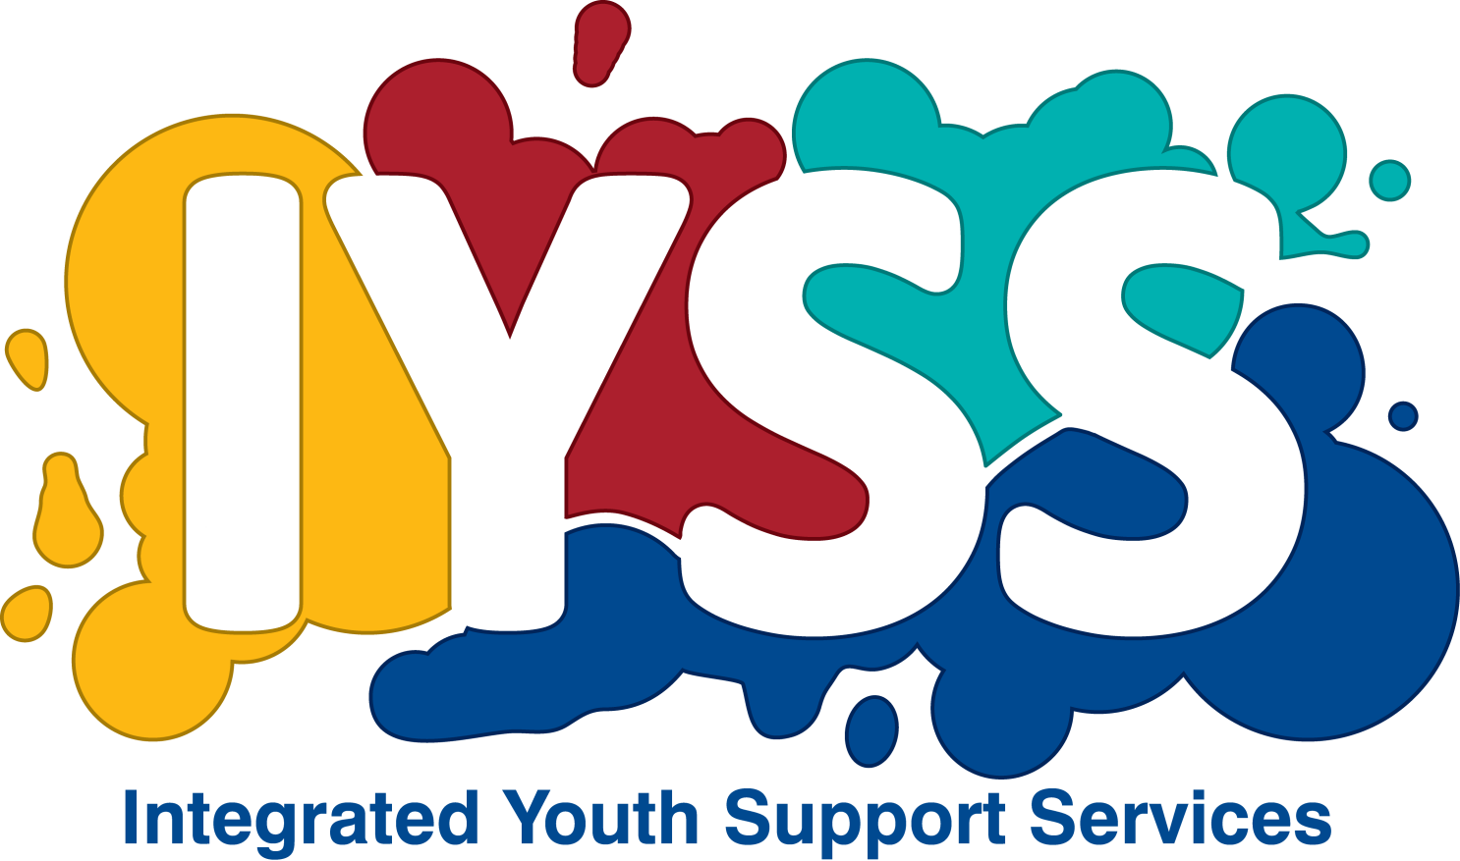TCLogo-150px.jpgTCLogo-150px.jpg

RESPECT is all about building healthy relationships. It’s a structured group programme consisting of 6 sessions for young people between the ages of 10-18yrs.

**Session 1** – Meet and explain. Let the individual know about the importance of confidentiality and assess any risk issues with attendance, contact or course materials.

**Session 2** – What is DA? Watch video and discuss. What is Jake doing? Why does Ellie respond the way she does? What do you notice about Ellie’s friends? Who can be a victim of DA? Who can be a perpetrator?

**Session 3** – DA the impact on children. What is the picture in the UK?

**Session 4** – How to build good relationships – respect, sharing, trust – what do they mean? Listening and managing disagreement – improving skills. Coping with jealousy – normal/abnormal emotions.

RESPECT

*… Building healthy relationships*

**Session 5** – What support is out there? The Police Response. The Court response (including stalking, harassment, revenge porn and sexual exploitation.)

**Session 6** – re-cap and lessons we have learnt. Share thoughts about DA. Signposting for support, treatment and recovery.

**If you would like to discuss the programme, please contact Susan Clarke or Becky Nuttall on 01803 208400 or alternatively you can email;** [susan.clarke@torbay.gov.uk](mailto:susan.clarke@torbay.gov.uk) / [becky.nuttall@torbay.gov.uk](mailto:becky.nuttall@torbay.gov.uk)