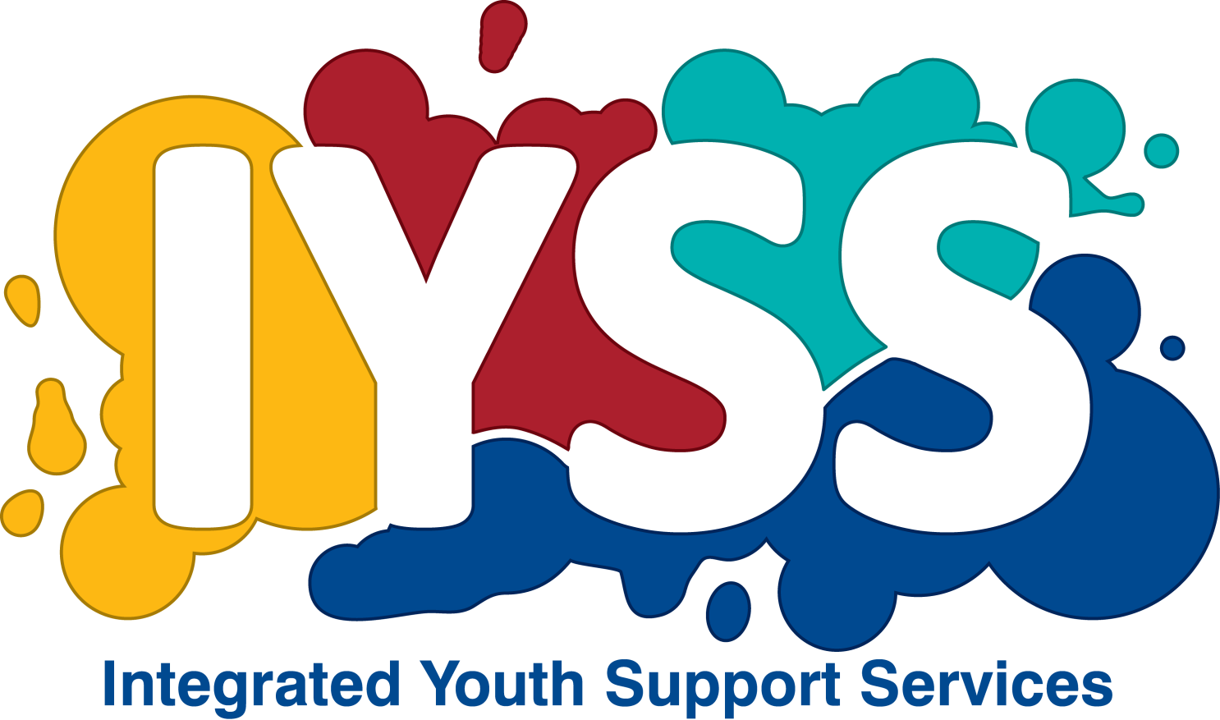

RESPECT...
…building healthy relationships
INTEGRATED YOUTH SUPPORT SERVICES
TORBAY COUNCIL
Tel: 01803 208400

REFERRAL CRITERIA: Young people aged 14 – 17 years who have perpetrated, witnessed and/or experienced domestic abuse.
Agency/organisation
Name of contact
Contact number
Email
Why are you referring the YP to the Respect programme? What is their experience of domestic abuse? Are they a perpetrator?
Full name
Preferred name
Dob |  |  |  |  |  | Age
Gender
Address
Preferred method of contact |  |  |  | Call landline
 |  |  |  | Text
 |  |  |  | Email
Is it safe to |  |  |  | Call
 |  |  |  | Leave a voicemail
 |  |  |  | Unsafe
Best time to contact
Does the YP have any medical conditions, disability or mobility problems, problems using stairs or a visual/hearing impairment?
YES / NO
Does the YP require language or literacy support?
YES / NO
Is the YP being supported by another agency? (social care, mental health, substance worker, YOT)
If YES please give brief details.
YES / NO

Is the YP using substances?
YES / NO

Is there anything else we should be aware of in order to ensure the YP’s comfort or safety – or the comfort or safety of staff and others?
e.g.: is the YP known to be violent or aggressive?
YES / NO

Does the YP have a child protection plan in place or involvement with Children’s Services?
YES / NO

If YES, please give brief details including social worker’s contact details.
YES / NO

Is the YP a looked After Child?
YES / NO
Is the family currently involved or had past involvement with MARAC?
YES / NO
What type of abuse is the YP experiencing? Please tick all that apply.
 | None |  |  |  |  |  | Risk of abuse in current relationship
 | Experienced abuse in the past |  |  |  |  |  | Exposed to abuse at home
 | Physical abuse |  |  |  |  |  | Emotional abuse
 | Financial abuse |  |  |  |  |  | Sexual violence or exploitation
 | Showing perpetrator traits and/or characteristics |  |  |  |  |  | Family involved with a CAF
 | Protection plan in place with Children’s Services |  |  |  |  |  | Family involved with MARAC
 | Involved with prostitution |  |  |  |  |  | Risk of forced marriage
 | Stalking or harassment |  |  |  |  |  | Risk of Honour based violence
 |  |  |  |  |  |  | At risk of being trafficked
If the YP is under 16, has parental consent been given for the YP to attend the Respect programme?
YES / NO
Name
Address
Phone number
Relationship
Can the YP safely attend a session and keep the service and venue confidential from any abusive party?
PLEASE NOTE: All referrals will be looked at on an individual basis to consider risk and vulnerability. Not all referrals will be accepted as a result.

