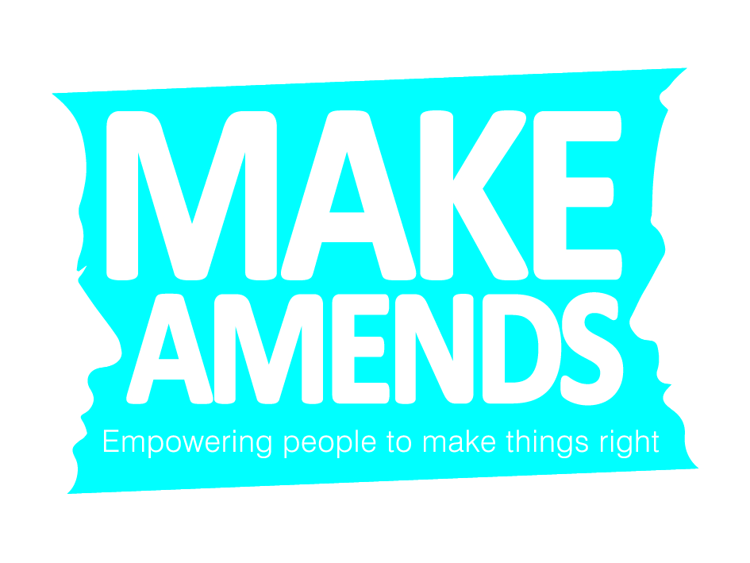

Email your referral securely to rebecca.rushton@makeamends.cjsm.net
Nature of referral: | Criminal Justice [ ] Voluntary [ ] School [ ] Community [ ] Other [ ]
Referrer contact information: |  |  |  |  |  |  | Date:

Name:
Organisation (if applicable):
Contact No:
Harmer contact information:
Name: |  |  |  | Date of Birth:
Address:
Main contact No: |  |  | Email address:
Safe contact details
What would this person like to achieve / see as an acceptable outcome?

Is there a preference for a male/female practitioner? YES [ ] NO [ ] Male: [ ] Female [ ]

HAS CONSENT TO SHARE INFORMATION BEEN GIVEN: YES [ ] NO [ ] *If No not able to proceed with referral
Main offence/ Details of harm caused:
Crime Number: |  |  |  |  | Date occurred:
Offence:
Brief description:
Court Sentence:
(if applicable)

Harmed contact information:
Name: |  |  | Date of Birth:
Address:
Main contact No: |  | Email Address:
Safe contact details:
What would this person like to achieve / see as an acceptable outcome?

Is there a preference for a male/female practitioner? YES [ ] NO [ ] Male: [ ] Female [ ]

HAS CONSENT TO SHARE INFORMATION BEEN GIVEN: YES [ ] NO [ ] *If No not able to proceed with referral

Notes on completion

You must have the consent of each party to refer to our service.

If you do not have access to a secure email exchange you must phone the office and arrange for a secure transfer of information for your referral.

